**Chapter 8 Exponential Equations REVIEW**

**(Show your work, please!)**

**Simplify each expression.**

**1. ** **2.  3.  4.  5. **

**Simplify the expression. When using exponents in your answer, they must be positive.**

**6.  7.  8. **

**9. Write an exponential equation for the table. 10. Write an exponential equation for the table.**

|  |  |  |  |  |
| --- | --- | --- | --- | --- |
| **x** | **-3** | **-2** | **1** | **2** |
| **y** | **3** | **6** | **48** | **96** |

|  |  |  |  |  |
| --- | --- | --- | --- | --- |
| **x** | **-2** | **-1** | **2** | **3** |
| **y** | **1000** | **100** | **0.1** | **0.01** |

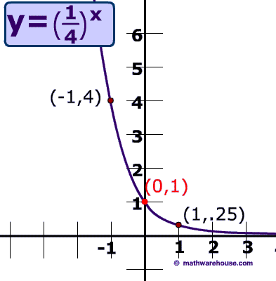

**11.** Decide whether the graph represents exponential growth or decay.

Then write an equation for the function.

**12a.** Seth has $2,100 in a saving account that earns 3% interest each year. Write a function that models the value of the savings account over time.

**12b.** How much will Seth have in his account after 15 years?

**13a.** Mrs. Schumann bought a car for $19,000 in 2005. Due to depreciation and use, the value of the car declined by about 14% per year. Write a function that models the value of the car over time.

**Using your answer from **13a** on the front**

**13b**. Estimate when will the car be worth less than $5,000?

**13c.** How much will the car be worth in 2018?

**14a.** An adult takes 30 mg of Motrin. Each hour, the amount of Motrin in the person’s system decreases by about 9%. Write a function that models the amount of Motrin in the body over time.

**14b.** How much Motrin is left after 6 hours?

**15a.** A chicken farm has 800 flies. The number of flies increases at a rate of about 3.2% per day. Write a function that models the amount of flies over time.

**15b.** Estimate how many days it will take for the number of flies to be more than double the initial amount of flies.

**Determine if each is a growth or decay. Then, write the exponential equation for the following table of values and graph the function.**

**16. 17.**

|  |  |
| --- | --- |
| x | y |
| -2 | 0.5 |
| -1 | 1 |
| 2 | 8 |
| 3 | 16 |
| 4 | 32 |

|  |  |
| --- | --- |
| x | y |
| -1 | 48 |
| 0 | 24 |
| 1 | 12 |
| 2 | 6 |
| 4 | 1.5 |

